Training Workshops


“The beautiful thing about learning is that nobody can take it away from you.” — B.B. King
Find Your Workshop
Our Focus Areas
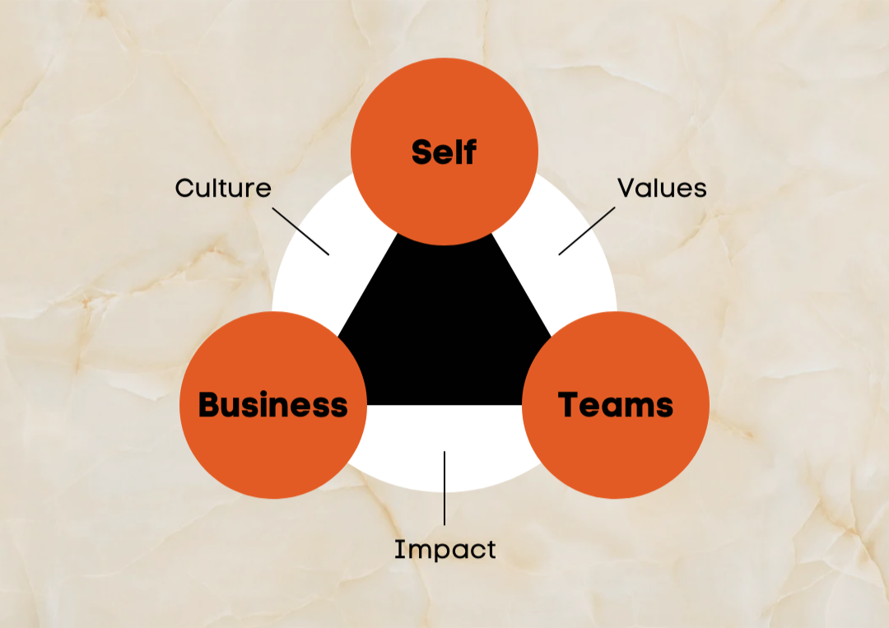

At BlewMinds, our passion lies in creating vibrant learning environments where participants actively engage & acquire new skills. Our workshops are carefully crafted to break away from traditional learning, blending hands-on activities, immersive exercises, lively group discussions, & expert group coaching guidance.
We offer workshops specifically designed to focus on Self development, Team development, as well as Organizational Development. Our unique approach follows a three-step framework, encompassing culture, values, & impact. Unlike typical 1-to-many lectures that simply deliver information, our approach encourages immersion through practical exercises, simulations & real world case studies, all tailored to specific goals of each client. Ultimately, our frameworks ensure that the impact of these workshops is not just felt but seen & is easily implementable in a sustained manner.
At the heart of our approach are experts who lead sessions designed to deliver immediate, applicable insights & results. We not only focus on enhancing individual skills but also foster team unity & drive organizational development. At BlewMinds, we are committed to enhancing your learning journey to make it both meaningful & transformative. Our fundamental approach is centered in psychology & scientific practices, which bring tangible results.
Our mission is to help you explore & connect deeply with your inner self & thoughts. Through this journey, you will experience greater clarity, enhanced emotional resilience, & a profound sense of purpose. This guidance into inner work unlocks your true potential, fostering personal growth & positive, long-lasting change.
Our Trainings also focus on the new age DEIB concept of Diversity, Equity, Inclusion & Belongingness. From Unconscious Bias break workshops to HeForShe interventions, including AntiSexual Harassment trainings, Employee Pulse surveys we offer both Strategy & Implementation of DEIB projects.
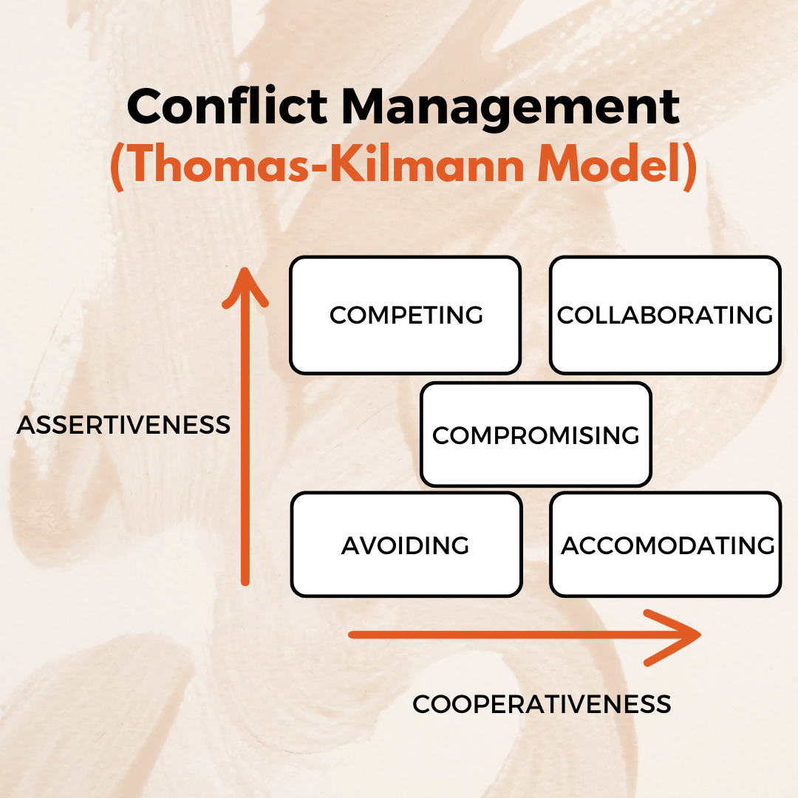

We utilize various models/frameworks that create real impact, enable self-reflection & a stronger inner voice. For instance, we use the Thomas-Kilmann Conflict Mode Instrument (TKI), a framework developed by Kenneth Thomas & Ralph Kilmann, as part of our Conflict Management Strategy workshops.
Through this approach, grounded in such global frameworks, we aim to equip our clients with versatile strategies that promote constructive resolution & foster positive interpersonal team dynamics.
Following the same Self-development, Team development & Organizational Development framework, a few critical competencies which we train & group coach on, are articulated below. Our Training Workshops are not limited to the same & are always customized to address our client's business problems.
Find Your Workshop
Offerings
Self-Development Workshops
Emotional Intelligence: Our emotional intelligence training cultivates self-awareness, empathy, & effective interpersonal skills, crucial for navigating complex organizational dynamics. We dive deep into understanding emotions, managing relationships, & fostering a more cohesive & supportive work environment, empowering individuals to connect more authentically with their peers.
- Resilience Building
- Perspective-Taking
Leadership Brand: We focus on developing Executive Presence & a strong Leadership Brand to enable clients to motivate teams towards shared goals, positioning our clients as impactful leaders in their fields. Through tailored sessions, we help leaders refine their Leadership Communication, establish a commanding presence, & build a powerful Personal Brand that reverberates with ingenuity & strength.
- Authentic Leadership
- Leadership Style
StoryTelling Laboratories: Our StoryTelling workshops empower clients to craft compelling narratives that resonate deeply & inspire action. For instance, StoryLab, our virtual StoryTelling workshop, enables individuals to take the first steps towards curating captivating stories. Through powerful self-reflection activities, hands-on exercises & personalized feedback, participants learn to weave facts & emotions into powerful & memorable tales.
- StoryTelling Skill Enhancement
- Self-Reflection
Vulnerable Leadership: Embracing Vulnerable Leadership principles, we foster trust, authenticity, & a culture of openness conducive to continuous learning & growth. Our workshops encourage leaders to embrace their imperfections, share their journeys, create an environment where honesty & vulnerability lead to deeper connections, mental clarity & innovative problem-solving.
- Authentic Expression
- Feedback Culture
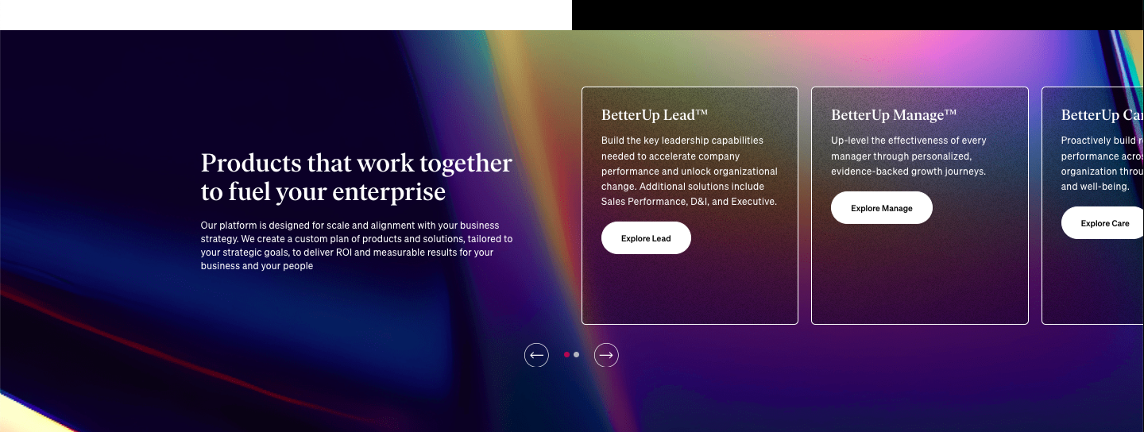

Team Development
Collaboration: At BlewMinds, we promote synergy among team members by harnessing diverse perspectives & strengths, fostering innovation & cohesive teamwork. Our training sessions are designed to break down silos, encourage creative problem-solving, & build a strong, united team.
- Constructive Conflict Resolution
- Team Building Activities
Crucial Conversations: Through our crucial conversations training, we facilitate open dialogue on sensitive topics, promoting clarity, alignment, & effective collaboration & connections toward shared objectives. These workshops help individuals communicate more effectively, ensuring that even the most challenging discussions lead to positive outcomes.
- Active Listening
- Cultural Awareness
Manager as a Coach: We focus on enhancing managerial effectiveness to empower leaders in inspiring & guiding their teams toward peak performance. Our approach balances task management with mentorship & supportive leadership, helping managers cultivate a productive & motivated workforce.
- Continuous Learning
- Responsive Leadership
- New Manager Effectiveness
Stakeholder Management: Understanding influence & power dynamics within organizations/teams is crucial for effective stakeholder management. We empower leaders to build trust, leverage strengths, & motivate team members toward achieving collective goals. Our workshops provide the tools & insights needed to navigate team dynamics with confidence & skill.
- Impact Assessment
- Progress Tracking


Organizational Development
Change Management: We provide essential change management skills to help clients navigate transitions smoothly, fostering adaptability & ensuring stakeholders embrace organizational shifts with confidence. Through personalized guidance & strategic insights, we address key obstacles, from career transitions to skill development. Participants gain clarity on their goals, receive actionable steps for advancement, & build resilience to flourish.
- Risk Assessment
- Alignment Strategies
Decision Making & Problem Solving: Our effective decision making workshops empower clients to evaluate options, assess risks & align choices with strategic goals to optimize outcomes. Our Interactive sessions focus on improving decision making & problem solving skills through immersive exercises, global frameworks & practical discussions. We aim to equip you with skills & strategies to make structured & well thought decisions in your personal as well as professional life.

- Data Analysis
- Structured Approach
Project Management: Our expertise in project management ensures initiatives are executed efficiently, deadlines are met & intended results are delivered within budget constraints, promoting operational excellence.
- Work Breakdown Structure (WBS)
- Variance Analysis
Strategic Thinking: Through thorough strategic thinking, we enable leaders to anticipate trends, identify opportunities & formulate long-term plans that drive growth within their organizations. By cultivating strong business acumen, our leaders gain a deep understanding of market dynamics, analyze financial data effectively & make informed decisions that enhance profitability & maintain competitive advantage.
- The OKR (Objective & Key Results) Model
- Strategic Alignment
- Strategy Formulation


Find Your Workshop

Impact of our workshops:
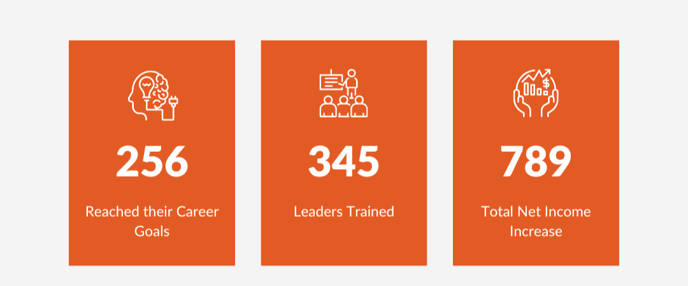

Form
FAQs
How will our workshops benefit you?
Our workshops are designed to provide you with practical skills & knowledge that facilitate professional & personal growth. Through networking opportunities with industry experts & peers, you will be able to broaden your perspectives & build valuable connections.
What is the outcome of our workshops?
At BlewMinds, we deliver comprehensive solutions tailored to boost the productivity of individuals & organizations. Our goal is to transform 5 billion lives by 2030, focusing on empowering individuals by using training as our methodology through the development & enhancement of their strengths.
Why should you join our Training Workshops?
Our programs provide hands-on learning experiences through interactive sessions led by seasoned experts. We offer flexibility to accommodate your specific needs & learning preferences, whether through personalized coaching, group workshops, or organizational competencies training.
Who are our Training experts in these workshops?
Sandeep Kochhar is an MBA from IIM Bangalore, an Electronics & Telecommunication Engineer with more than 18 years of Corporate Consulting experience. He is an insightful innovative powerful inspirational Speaker & Storyteller. He loves using StoryTelling as an instrument to change & transform. He has 30+ years of experience in poetry, StoryTelling & creative writing. He is Certified Leadership Coach & has been a coach to Forbes 30 under 30 Ecommerce entrepreneurs, Top Leaderships, CXOs of various industries/organizations as well as LGBTQ++ Community members.

Vishwapriya Kochhar is a Change Transformation Coach, an Organization Development Strategist, a Culture Change Specialist, a Human Resources Board Level Advisor, an Aficionado of Human Behavior & a crazy mommy to her 16 year-old hyper little geek. She began her Coaching journey to end her own games of playing the victim & wanting to help others, while she helps herself. She is a big Rumi (poet & philosopher) fan, applies these dreamy inspirations to her logical Coachees & also tries to get her dreamy Coachees to experience the fatal realities of the world.
Will the workshops be held online or in person?
We offer our sessions in both online & offline formats to cater to a range of preferences & requirements. Whether you opt for the convenience & flexibility of virtual sessions or the immersive experience of in-person workshops, we customize our approach to maximize your learning & engagement.
Keywords: Training workshops | Self development workshops | Leadership | Emotional Intelligence | StoryTelling
Focus: Training Workshops
Meta Description: BlewMinds’ Training Workshops are designed to provide you with practical skills & knowledge that facilitate professional & personal growth. Learn more.

